**BANKING MANAGEMENT SYSTEM**



Session: 2021 – 2024

**Submitted by:**

Ali Haider Khan 2021-CS-38

**Supervised by:**

Professor Dr. Awais Hassan

Department of Computer Science

**University of Engineering and Technology**

**Lahore Pakistan**

**Description:**

My Project is a simple Banking Management System. It has two users. One is admin and other is costumer. Admin can add account, view all records, check money etc, after entering his correct username and password. Costumer can only open account after registering himself from admin. Admin can add accounts up to 100. Admin can see total money in the bank. After registering himself from Admin, Customer can deposit money and can withdraw money. Customer can transact money to another account after entering right account number. Customer can see see his deposit money history, withdraw history, transact history and received money history. Costumer can see his account details.

**Users:**

There are two users of this application

* One is Admin
* And other is Costumer

**Functional Requirements:**

**For Admin:**

1. As a Admin, I can add Accounts
2. As a Admin, I can view all accounts
3. As a Admin, I can View all account in sorting order in term of money
4. As a Admin, I can See Any Loan Request
5. As a Admin, I can check total money in the bank

**For Costumer:**

1. As a Costumer, I can Deposit Money
2. As a Costumer, I can Withdraw Money
3. As a Costumer, I can Transact Money
4. As a Costumer, I can see Deposit Money Details
5. As a Costumer, I can see Withdraw Money Details
6. As a Costumer, I can see Transact Money Details
7. As a Costumer, I can see Received Money Details
8. As a Costumer, I can check all my balance Records
9. As a Costumer, I can see all my Account Details

**Wireframes:**

**1-Home**

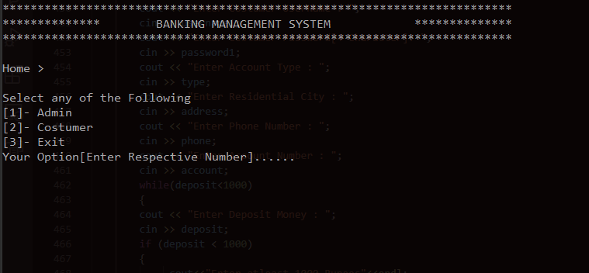**2-Admin Log in**

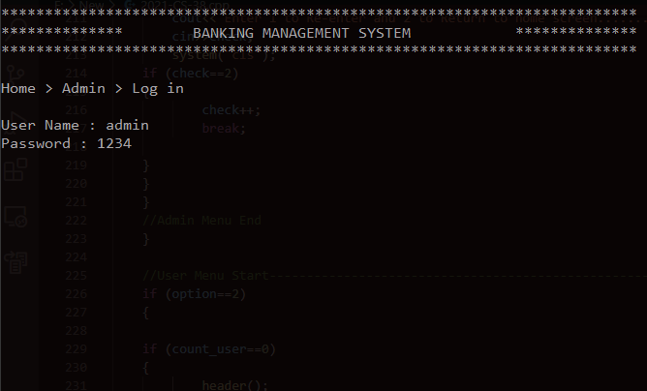

**3-User Log in(As there is no account till now)**

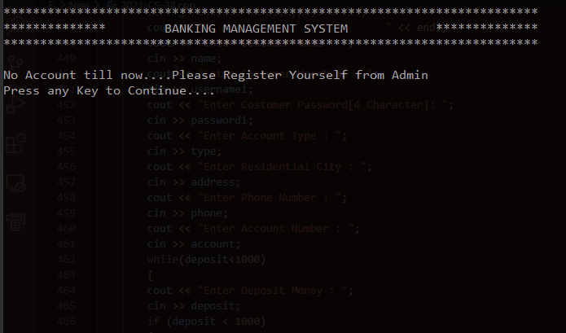**4-Admin Menu**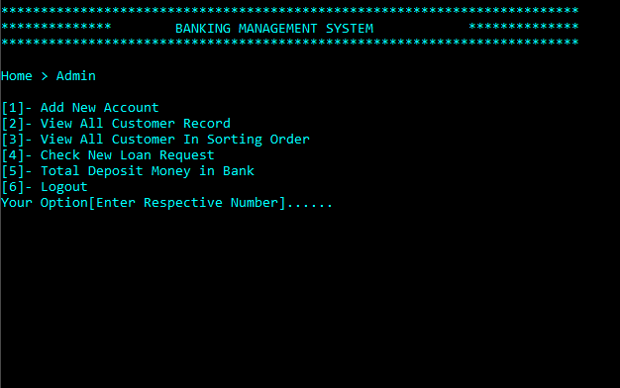

**5-Add Account**

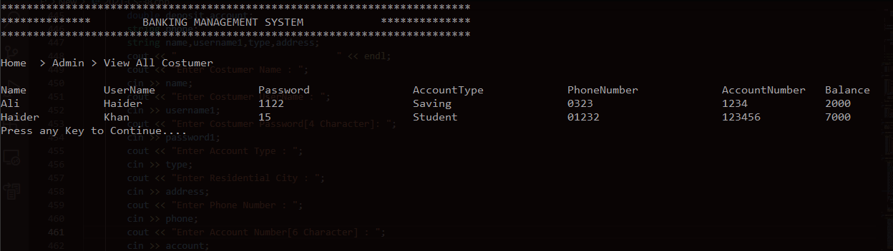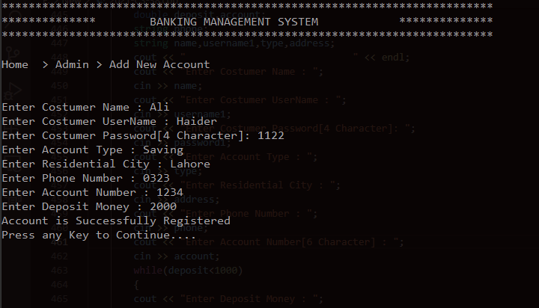**6-View all Costumer**

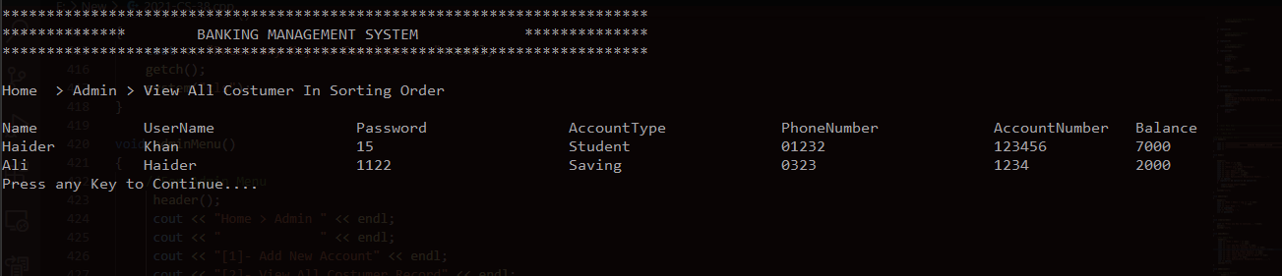**7-View all Costumer in Sorting Order**

**8-View Loan Request**

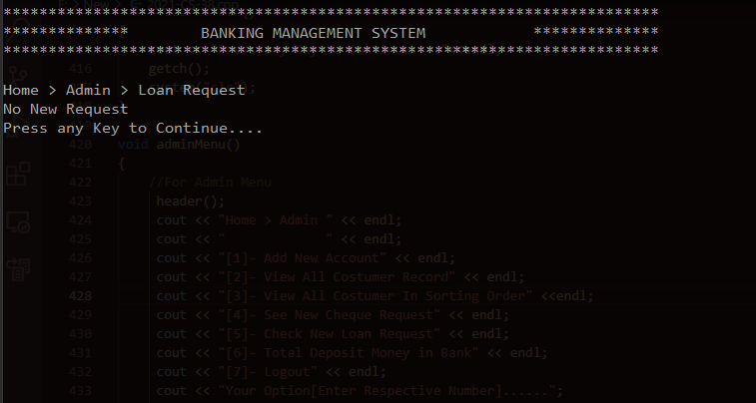

**10-Total Money in the Bank** 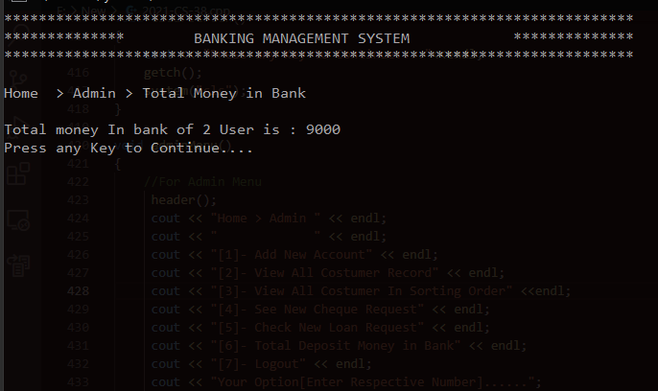

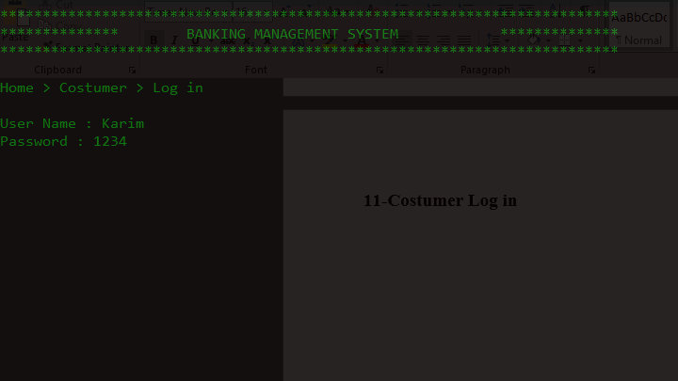**11-Costumer Log in**

**12-Costumer Menu**

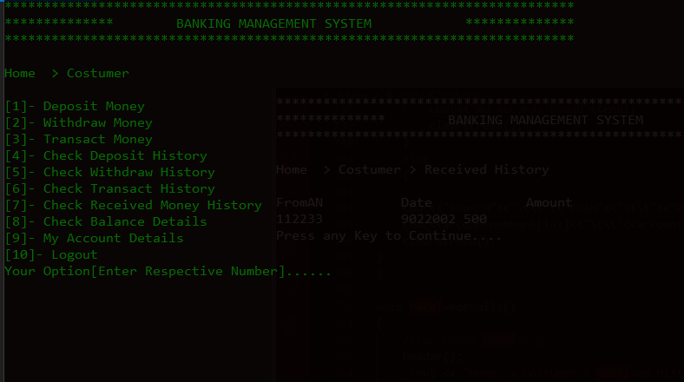

**13-Deposit Money**

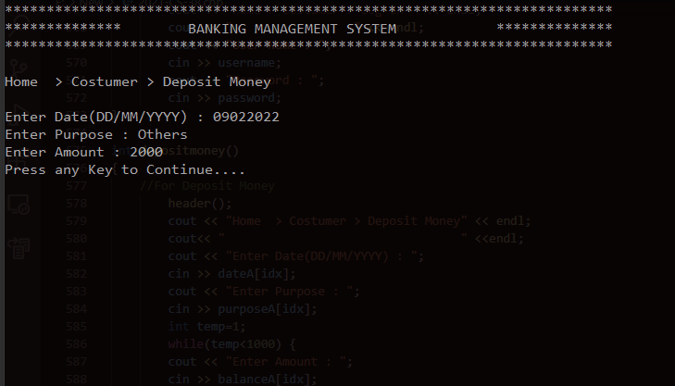

**14-Withdraw Money**

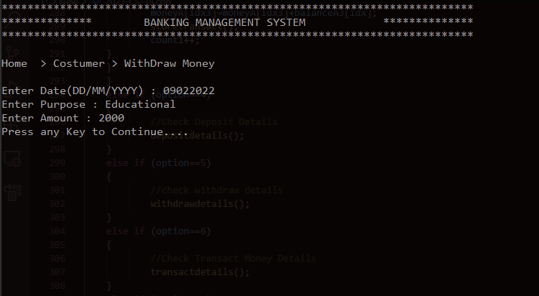

**14-Transact Money**

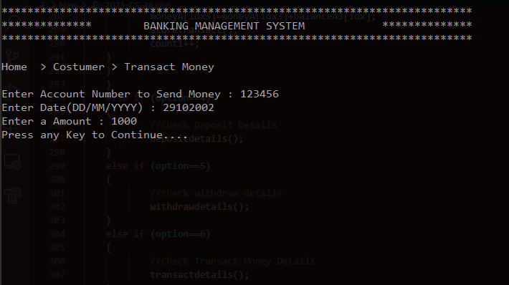

**15-View Deposit History**

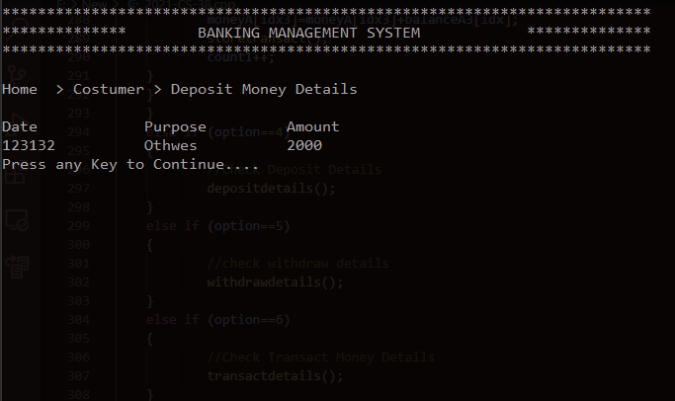

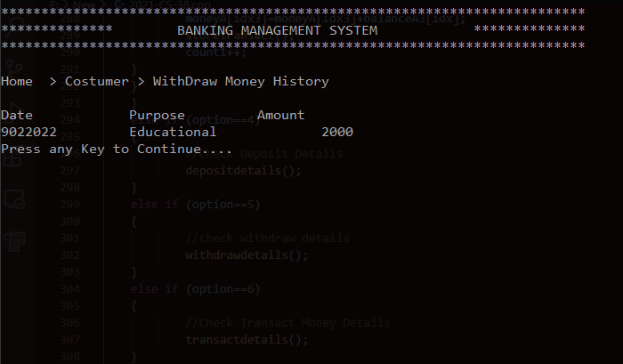**16-View Withdraw Money**

**17-View Transact Money**

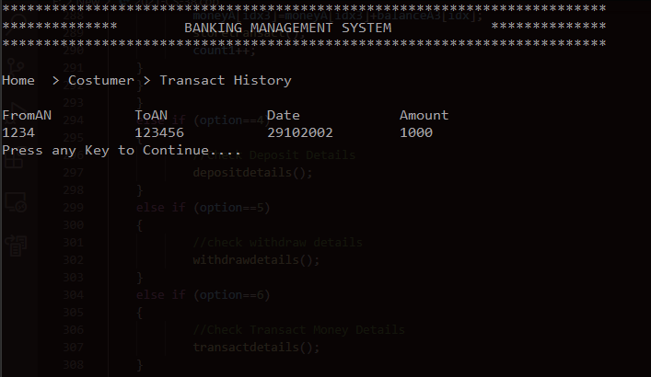

**18-View Received Money**

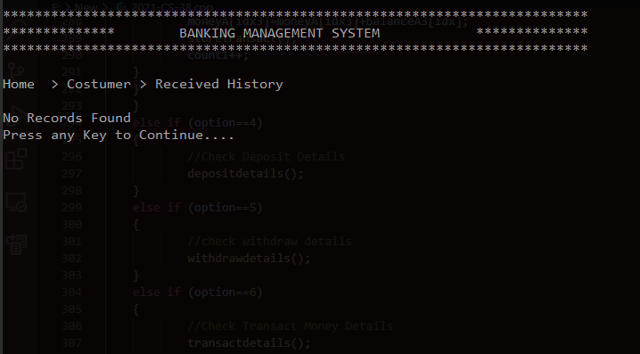

**19-Balance Details**

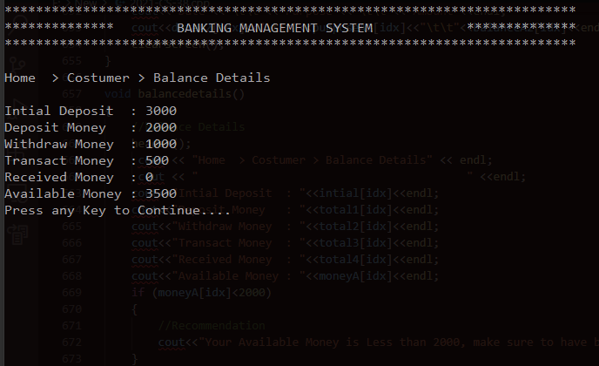

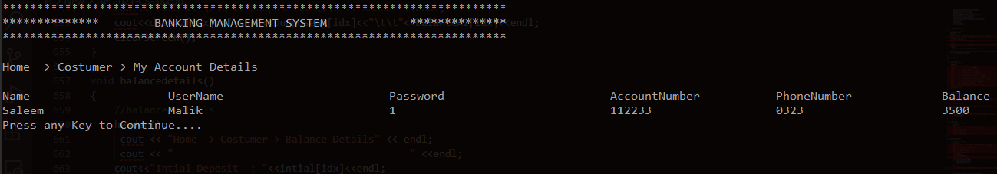**20-My Account Details**

**21-Received Money in Other Account**

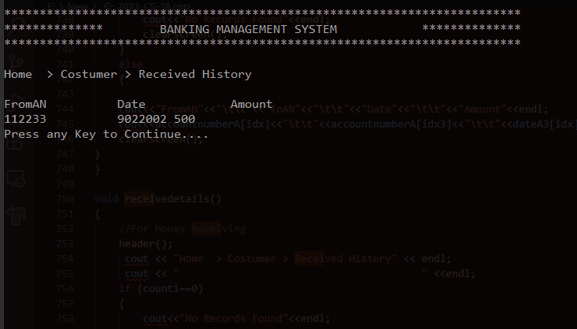

**Test Cases:**

* **Wrong Input**

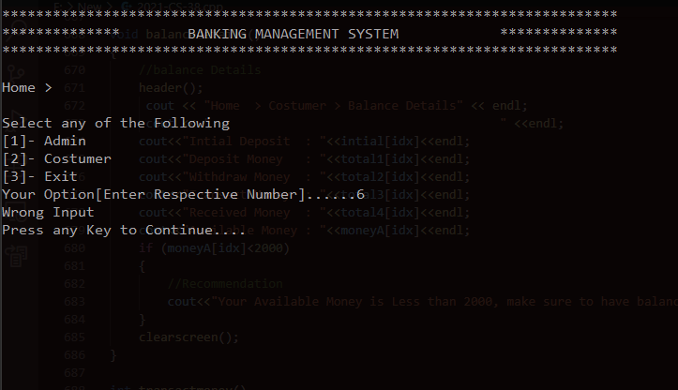

* 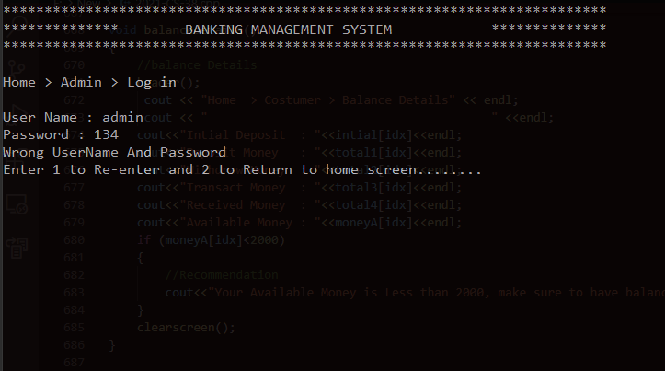**Wrong User Name and Password of Admin**
* 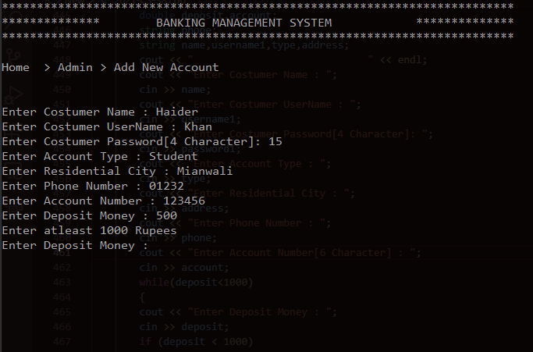**In creating account deposit money should be more than 1000**
* 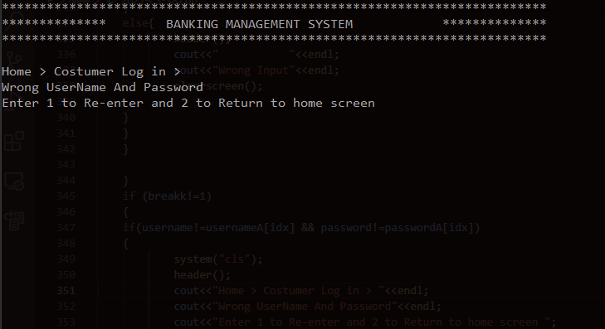**Wrong User Name and Password of Costumer**
* 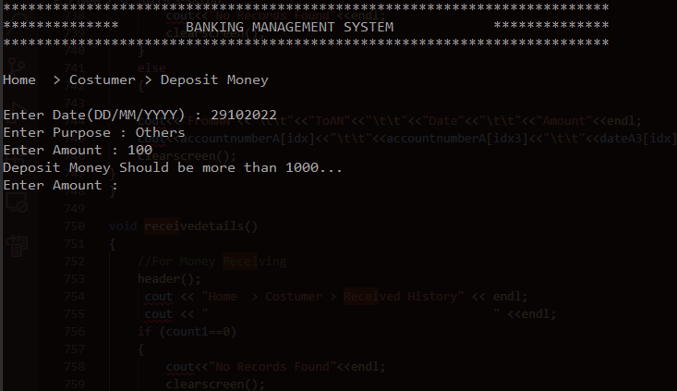**Deposit Money Should be more than 1000**
* 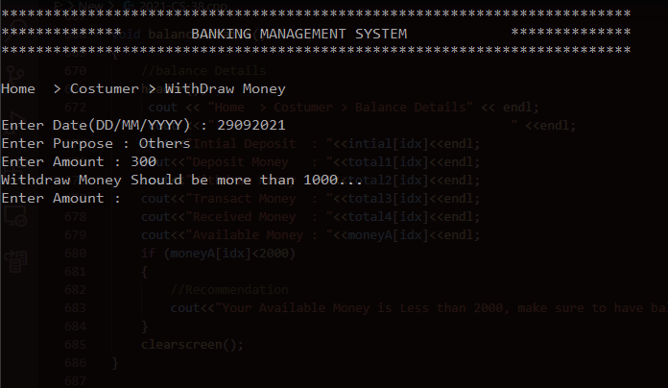**Withdraw should be more than 1000**
* 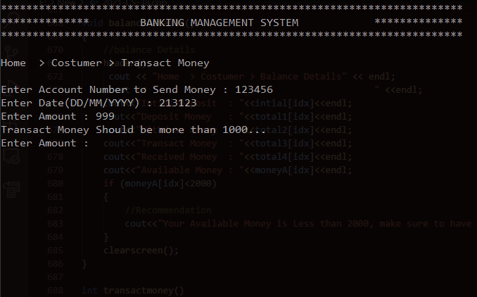**Transact Money Should be more than 1000**
* 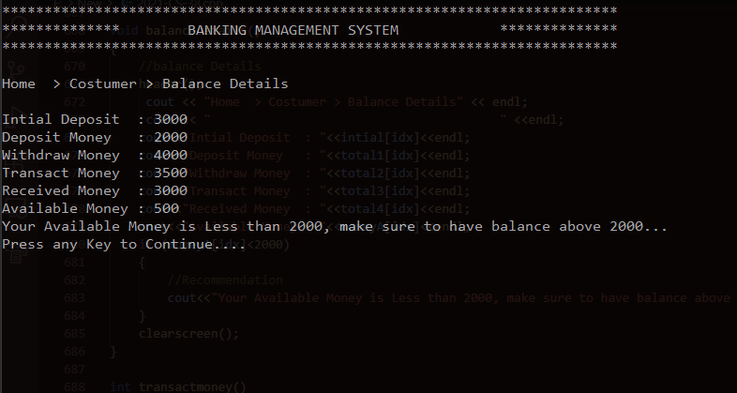**Recommendation in case of less than 2000 available balance**
* 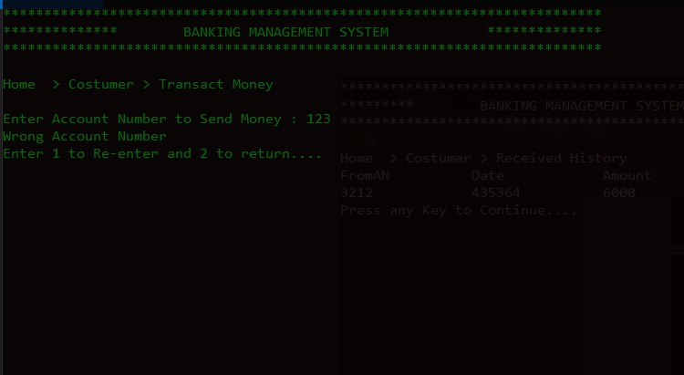**Cannot Transact Money till right Account Number is Entered**

**Limitation:**

* You cannot use space, instead use underscore
* There should be no special character in Password
* Should enter correct input datatype otherwise program will terminate